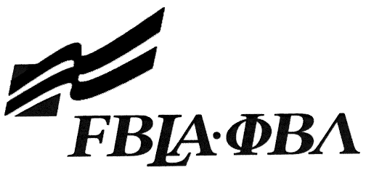 FBLA Statement of Assurance

National Event Entry Form
This form must be completed and attached to each copy of the media. For state competition, mail to your state adviser not the national office. For NLC Internet events, complete and email this form to education@fbla.org and your state adviser. For other national events, complete and include this form with your submitted materials. For national competition this is due by the second Friday in May.

Check one: 3D Animation Computer Game & Simulation Programming
Desktop Application Programming Digital Design & Promotion
Digital Video Production (URL to State Adviser) E-business (URL to State Adviser)
Mobile Application Development Website Design (URL to State Adviser)

Provide the complete URL for E-business, Digital Video Production, and Website Design. These events will be judged online. Make sure the URL link is valid through the National Leadership Conference.

KEY INFORMATION
State: | New York State
School: |  | Mamaroneck High School
Website URL Address: (where appropriate—must have full address) |  | N/A
Member(s) Name: |  | Andrew Katz
Local Chapter Contact
Name: | Maria Siciliano
Daytime/Cell Number: | 914 424-6018
Home E-mail: | msiciliano@mamkschools.org
I/We, the undersigned, attest that the design, creation, and implementation of the event are the original work of the above chapter member(s). I/we agree that this event may be linked, promoted, and used in any way by the national FBLA-PBL, Inc. for purposes of promoting the association. (Typed name is accepted for signature)
Name of Team Member  Andrew Katz |  | Adviser’s Name
Name of Team Member |  | Name of Team Member
Complete this Document Section for the Above Events if Applicable
Software Used: | Android Studio for Windows
Source of Information: | School website
Copyright Notations | Please see COPYRIGHT.pdf on the DVD
Instructions for Running Project: | Please see README.html on the DVD. If problems occur, please email aakatz4@live.com
Template(s) Used (source) | Standard android templates.

